Course Scheme for Post Graduate Programme

in

Instrumentation and Control Engineering

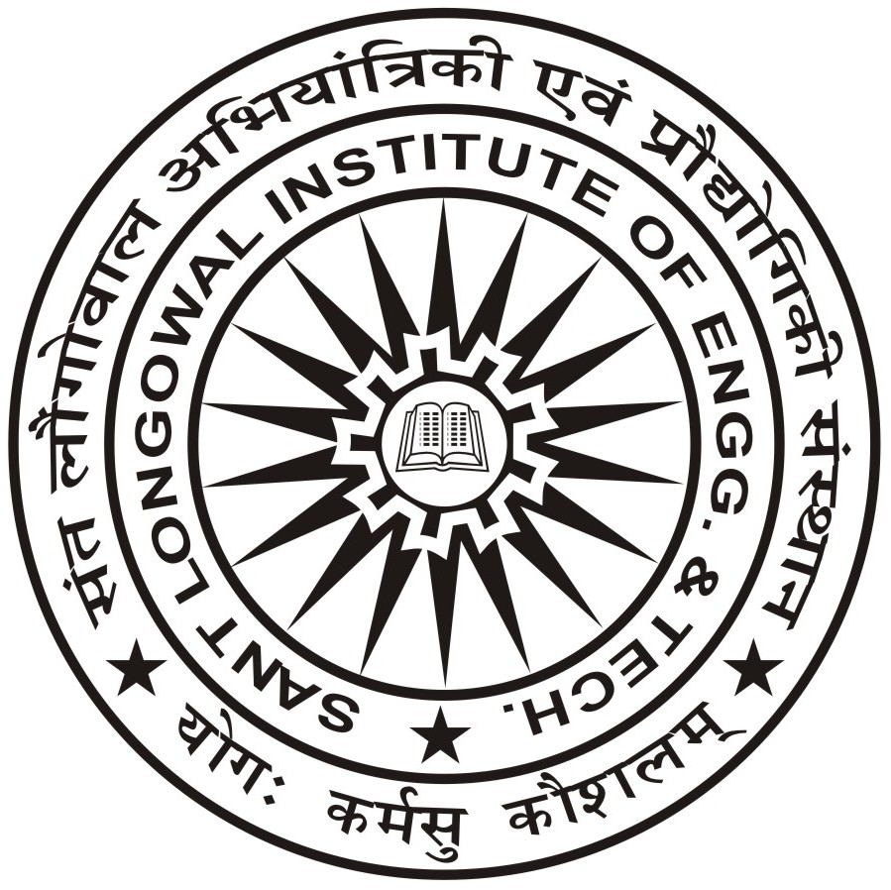

Department of Electrical & Instrumentation Engineering

Sant Longowal Institute of Engineering & Technology
Longowal-148106
Phone: 01672-253119/253120 Fax: 01672-280057
Website: www.sliet.ac.in

M.TECH. (CONTROL AND INSTRUMENTATION ENGINEERING)
Semester-I
S. No. | Subject Code | Subject Name | L | T | P | Hrs. | Credits
1 | PCIE-811 | Instrumentation System Design | 3 | 0 | 0 | 3 | 3
2 | PCIE-812 | Non-Linear and Adaptive Control | 3 | 0 | 0 | 3 | 3
3 | PEIE-811 | Core Elective-1 | 3 | 0 | 0 | 3 | 3
4 | PEIE-812 | Core Elective-2 | 3 | 0 | 0 | 3 | 3
5 | CCIE-811 | Research Methodology and IPR | 2 | 0 | 0 | 2 | 2
6 | ACIE-811 | Audit Course-1 | 2 | 0 | 0 | 2 | 0
7 | PCIE-813 | Instrumentation System Design Lab | 0 | 0 | 4 | 4 | 2
8 | PCIE-814 | Modelling and Simulation Lab–I | 0 | 0 | 4 | 4 | 2
 |  | Total | 16 | 0 | 8 | 24 | 18
Semester-II (A)
Sr. No. | Subject Code | Subject Name | L | T | P | Hrs. | Credits
1 | PCIE-821 | Industrial Process Control | 3 | 1 | 0 | 4 | 4
2 | PCIE-822 | Advanced Bio-Medical Instrumentation | 3 | 0 | 0 | 3 | 3
3 | PEIE-821 | Core Elective-3 | 3 | 0 | 0 | 3 | 3
4 | PEIE-822 | Core Elective-4 | 3 | 0 | 0 | 3 | 3
5 | ACIE-821 | Audit Course-2 | 2 | 0 | 0 | 2 | 0
6 | PCIE-823 | Advanced Bio-Medical Instrumentation Lab | 0 | 0 | 4 | 4 | 2
7 | PCIE-824 | Modelling and Simulation Lab–II | 0 | 0 | 4 | 4 | 2
8 | PCIE-825 | Seminar | 0 | 0 | 2 | 2 | 1
 |  | Total | 14 | 1 | 10 | 25 | 18
Semester-II (B)
 | Four weeks training in reputed industry/laboratory in Institutions of repute such as IITs, NITs, CSIR, DRDO, CSIO etc. |  |  |  |  | 160 | S/US
Semester-III
Sr. No. | Subject Code | Subject Name | L | T | P | Hrs. | Credits
1 | PEIE-911 | Core Elective-5 | 3 | 0 | 0 | 3 | 3
2 | OEIE-911 | Open Elective | 3 | 0 | 0 | 3 | 3
3 | PCIE-911 | Dissertation (Part-1) | 0 | 0 | 20 | 20 | 10
 |  | Total | 6 | 0 | 20 | 26 | 16
Semester-IV
Subject Code |  | Subject Name | L | T | P | Hrs. | Credits
PCIE-921 |  | Dissertation (Part-2) | 0 | 0 | 32 | 32 | 16
Total |  |  | 0 | 0 | 32 | 32 | 16
Total Credits: 68

LIST OF PROGRAM SPECIFIC/ CORE ELECTIVE COURSES
CORE ELECTIVE-1 (PEIE-811)
Sr. No. | Subject Code | Subject Name
1 | PEIE-811A | Data Communication
2 | PEIE-811B | Microcontroller and Embedded Systems
3 | PEIE-811C | Instrumentation for Environmental Engineering
4 | PEIE-811D | Power Plant Instrumentation
CORE ELECTIVE-2 (PEIE-812)
Sr. No. | Subject Code | Subject Name
1 | PEIE-812A | Random and Stochastic Processes
2 | PEIE-812B | Energy Auditing and Management
3 | PEIE-812C | Power System Stability and Control
4 | PEIE-812D | Neuro Fuzzy Control
CORE ELECTIVE-3 (PEIE 821)
Sr. No. | Subject Code | Subject Name
1 | PEIE 821A | Industrial Process Control
2 | PEIE 821B | Telemetry and Remote Control
3 | PEIE 821C | Multi Range Signal Processing
4 | PEIE-821D | Industrial Electronics
CORE ELECTIVE-4 (PEIE 822)
Sr. No. | Subject Code | Subject Name
1 | PEIE 822A | Optimal and Robust Control
2 | PEIE 822B | Computational Electromagnetics
3 | PEIE 822C | Control System Design
4 | PEIE-822D | Intelligent Control
CORE ELECTIVE-5 (PEIE 911)
Sr. No. | Subject Code | Subject Name
1 | PEIE 911A | Microprocessor Applications in Instrumentation
2 | PEIE 911B | Robotics Engineering
3 | PEIE 911C | Opto Electronics and Instrumentation
4 | PEIE-911D | System Identification and Parameter Estimation

OPEN ELECTIVE COURSE (OEIE-911)
Sr. No. | Subject Code | Subject Name
1 | OEIE-911A | Microcontroller and Embedded Systems
2 | OEIE-911B/ PEIE-812B | Energy Auditing and Management
3 | OEIE-911C | Virtual Instrumentation and Data Acquisition
4 | OEIE-911D | Industrial Safety
5 | OEIE-911E | Soft Computing Techniques
6 | OEIE-911F | Medical Image Processing
7 | OEIE-911G | Solar and Wind Power Technologies

